Animation Examples
Example 1
<div class="w-12 h-12 border-4 border-blue-500 border-t-transparent rounded-full animate-spin"></div>
How it works:
- w-12 h-12 → Sets width and height of the spinner.
- border-4 → Sets border thickness.
- border-blue-500 → Sets border color.
- border-t-transparent → Makes the top border transparent so the spin effect is visible.
- rounded-full → Makes it a perfect circle.
- animate-spin → Applies Tailwind’s built-in infinite rotation animation.
Example 2
<div class="animate-pulse bg-gray-300 h-4 w-32 rounded"></div>
animate-pulse is a utility class (often in frameworks like Tailwind CSS) that creates a gentle, repeating fade-in/fade-out or grow/shrink effect
Example 3
<div class="animate-bounce text-center text-blue-500">Click Me!</div>
text-center refers to the alignment of text so that it is centered horizontally within its container
Example 4
<div class="transition-transform duration-500 hover:scale-110 bg-blue-500 p-4 rounded-3xl">
Example 5
<html>
<head>
<title>Practice Website</title>
<link rel="stylesheet" href="./input.css">
</head>
<body class="bg-yellow-100">
<p class="text-center m-4">This is Transition Example</p>
<div class="w-fit border border-black mx-auto grid grid-cols-2 gap-2 p-2">
<div>
<button class="bg-green-200 rounded-3xl w-46 p-2 transition-transform delay-1000 ease-linear
hover:scale-90 hover:text-white
hover:text-blue-500">Click Me:)</button>
</div>
<div>
<button class="bg-green-200 rounded-3xl w-46 p-2 transition-transform delay-500 ease-linear
hover:scale-90 hover:text-white
hover:font-medium">Click Me:)</button>
</div>
<div>
<button class="bg-green-200 rounded-3xl w-46 p-2 transition-transform delay-500 ease-linear
hover:scale-90 hover:text-white
hover:font-medium">Click Me:)</button>
</div>
<div>
<button class="bg-green-200 rounded-3xl w-46 p-2 transition-transform delay-500 ease-linear
hover:scale-90 hover:text-white
hover:font-medium">Click Me:)</button>
</div>
</div>
</body>
</html>
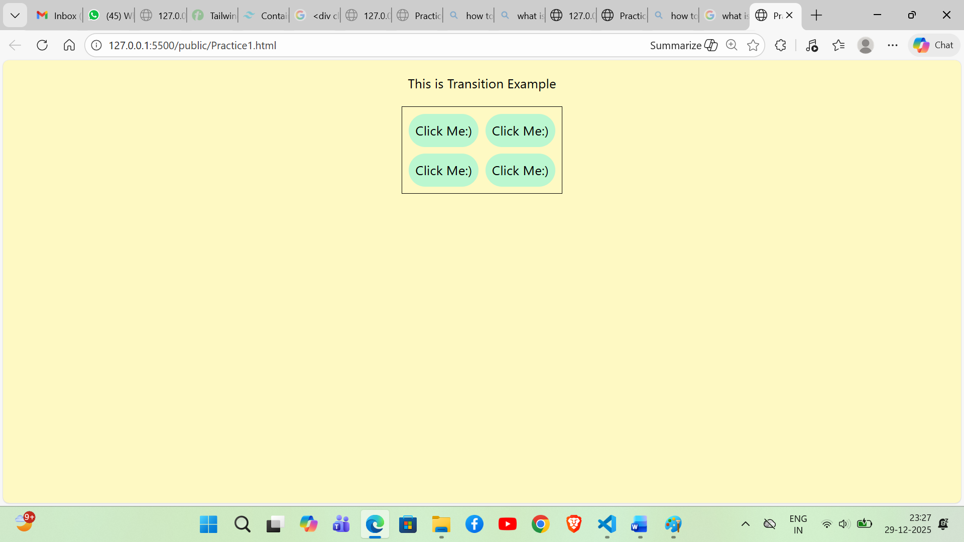

Example 6

<html>
<head>
<title>Practice2 Website</title>
<link rel="stylesheet" href="./input.css">
</head>
<body class="p-40">

<div class="hover:animate-bounce relative h-20 w-20 rounded-full bg-yellow-500 flex items-center justify-center shadow-lg">
<div class=" absolute h-5 w-5 top-5 left-3 bg-black rounded-full "></div>
<div class="absolute h-5 w-5 top-5 right-3 bg-black rounded-full "></div>
<div class="absolute bottom-3 h-4 w-8 bg-black rounded-b-full "></div>
</div>
<p> Hover Me to bounce </p>
<div class="hover:animate-spin relative h-20 w-20 rounded-full bg-yellow-500 flex items-center justify-center shadow-lg">
<div class=" absolute h-5 w-5 top-5 left-3 bg-black rounded-full "></div>
<div class="absolute h-5 w-5 top-5 right-3 bg-black rounded-full "></div>
<div class="absolute bottom-3 h-4 w-8 bg-black rounded-b-full "></div>
</div>
<p> Hover Me to spin </p>

</body>
</html>

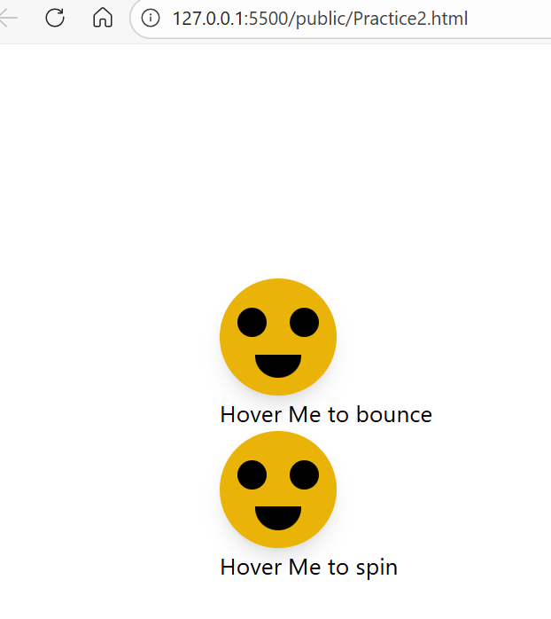

Example 7
<!DOCTYPE html>
<html>
<head>
<script src="https://cdn.tailwindcss.com"></script>
</head>
<body class="p-8">
<h2 class="text-2xl font-bold mb-3">
Tailwind CSS Transform Classes
</h2>
<div class="flex gap-6 flex-wrap">
<div class="w-28 h-28 p-6 bg-green-500 text-center font-bold
text-white text-center font-bold text-white
hover:scale-75 duration-500 ">
Hover: Scale-75
</div>
<div class="w-28 h-28 p-6 bg-green-500 text-center font-bold
text-white text-center font-bold text-white
hover:rotate-90 duration-500 ">
Hover: rotate-90
</div>
<div class="w-28 h-28 p-6 bg-green-500 text-center font-bold
text-white text-center font-bold text-white
hover:translate-y-6 duration-500 ">
Hover: translate-y-6
</div>
<div class="w-28 h-28 p-6 bg-green-500 text-center font-bold
text-white text-center font-bold text-white
hover:skew-x-12 duration-500 ">
Hover: skew-x-12
</div>
<div class="w-28 h-28 p-3 bg-green-500 text-center font-bold
text-white text-center font-bold text-white
hover:origin-bottom-right hover:rotate-45
duration-500 ">
Hover: origin-bottom-right
</div>
</div>
</body>
</html>

